SIMATS ENGINEERING
ASSESSMENT TOOL 1-Constraint Based Problem Solving

COURSE NAME: R PROGRAMMING COURSE CODE: ITA04

COURSE OUTCOME COVERED

CO: Apply R programming fundamentals including data structures, vectors, matrices, arrays, and class types to perform mathematical operations and manage data effectively.
(Bloom Level -BL2- BL4)

Assessment Tool Weightage: 20%

QUESTIONS: Total Marks: 100

1.Student Marks Analysis (Vectors) – BL2
Problem Statement:
A teacher has stored the marks of 10 students in a vector.
Constraints:
- Do not use built-in functions like sort().
- Use only vector indexing and arithmetic operators.
- Display the highest, lowest, and average marks.

2. Employee Salary Matrix – BL3
Problem Statement:
A company stores employee salaries of four departments in a 4 × 3 matrix, where rows represent departments and columns represent Basic Pay, HRA, and DA.
Constraints:
- Do not create separate vectors.
- Calculate total salary department-wise using matrix operations only.
- Display the department with the maximum total salary.

3. Rainfall Data (Arrays) – BL3
Problem Statement:
A meteorological department records rainfall for 3 cities, 4 seasons, and 2 years in a three-dimensional array.
Constraints:
- Use only array indexing.
- Find the city with the highest annual rainfall.
- Do not convert the array into a matrix or data frame.

4. Hospital Patient Records (Lists) – BL4
Problem Statement:
A hospital stores patient details (ID, Name, Age, Blood Group, Bill Amount) in a list.
Constraints:
- Store different data types in a single list.
- Retrieve only patients aged above 60.
- Calculate the average hospital bill without converting the list into another data structure.

5. Product Inventory (Factors) – BL3
Problem Statement:
A supermarket stores product categories (Electronics, Grocery, Stationery) using factors.
Constraints:
- Count the number of products in each category.
- Do not use table().
- Display categories in alphabetical order.
6. Cricket Performance Analysis (Data Frames) – BL4
Problem Statement:
A cricket academy maintains player records containing Name, Matches, Runs, Wickets, and Strike Rate.
Constraints:
- Identify players with Strike Rate greater than 120.
- Compute the average runs scored.
- Do not use SQL queries or external packages.

7. Bank Transaction Processing (Class Types) – BL3
Problem Statement:
A bank stores account numbers, customer names, balances, and account status.
Constraints:
- Identify the class of every column.
- Convert the account status into a factor.
- Ensure balances remain numeric after conversion.

8. University Attendance Management (Vectors and Logical Operations) – BL4
Problem Statement:
Attendance percentages of 15 students are stored in a vector.
Constraints:
- Students with attendance below 85% are not eligible for examinations.
- Display eligible and ineligible students separately.
- Calculate the percentage of eligible students.

9. Electricity Consumption Analysis (Matrices) – BL4
Problem Statement:
Monthly electricity consumption of 5 buildings over 12 months is stored in a matrix.
Constraints:
- Calculate annual consumption for each building.
- Identify the building with the highest consumption.
- Use matrix operations only.

10. Sales Performance Dashboard (Vectors, Matrices, Arrays, and Class Types) – BL4
Problem Statement:
A retail company stores:
- Monthly sales in a vector,
- Quarterly sales in a matrix,
- Regional sales in a three-dimensional array,
- Product categories as factors.
Constraints:
- Compute total annual sales.
- Identify the best-performing region.
- Compare quarterly performance.
- Verify the class type of every object before performing calculations.
- Use only base R functions.

Code of Conduct:

I ___Adhithyan S (192421102)_ (Name / Reg No) certify that this submission is my original work and that I have adhered to the guidelines specified for this assessment.
I understand that any violation of academic integrity rules will result in disciplinary action.
Signature of the student:
ANSWERS:
1. Student Marks Analysis (Vectors)

# Student Marks Analysis
marks <- c(78, 92, 85, 67, 90, 88, 76, 95, 81, 73)
highest <- marks[1]
lowest <- marks[1]
sum_marks <- 0
for(i in 1:length(marks))
{
if(marks[i] > highest)
highest <- marks[i]
if(marks[i] < lowest)
lowest <- marks[i]
sum_marks <- sum_marks + marks[i]
}
average <- sum_marks / length(marks)
cat("Highest Marks =", highest, "\n")
cat("Lowest Marks =", lowest, "\n")
cat("Average Marks =", average, "\n")
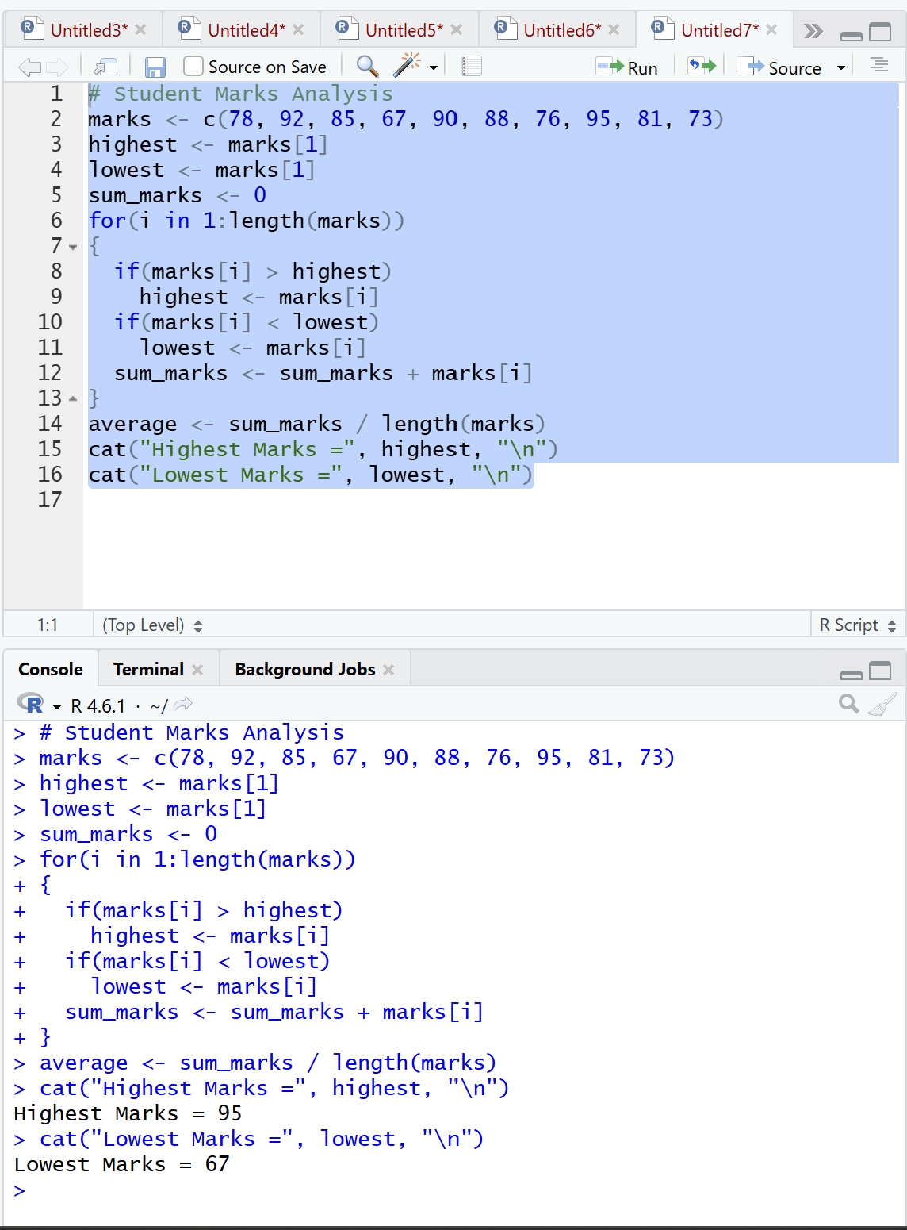

2. Employee Salary Matrix

# Employee Salary Matrix
salary <- matrix(c(
25000,5000,3000,
28000,6000,3500,
30000,7000,4000,
27000,5500,3200
), nrow=4, byrow=TRUE)
total_salary <- salary[,1] + salary[,2] + salary[,3]
cat("Department-wise Total Salary:\n")
print(total_salary)
max_dept <- 1
for(i in 2:length(total_salary))
{
if(total_salary[i] > total_salary[max_dept])
max_dept <- i
}
cat("Department with Maximum Salary = Department", max_dept, "\n")
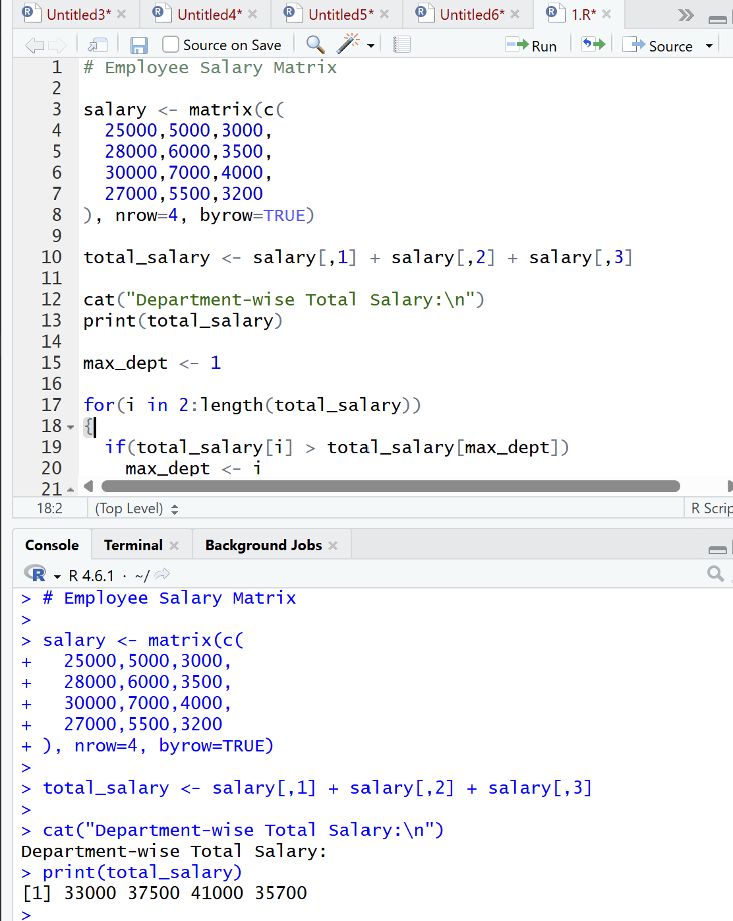

3. Rainfall Data (Arrays)

# Rainfall Data
rainfall <- array(c(
120,130,140,150,125,135,145,155,
100,110,120,130,105,115,125,135,
150,160,170,180,155,165,175,185
), dim=c(3,4,2))
annual <- c(0,0,0)
for(city in 1:3)
{
total <- 0
for(season in 1:4)
{
for(year in 1:2)
{
total <- total + rainfall[city,season,year]
}
}
annual[city] <- total
}
print(annual)
max_city <- 1
for(i in 2:3)
{
if(annual[i] > annual[max_city])
max_city <- i
}
cat("City with Highest Annual Rainfall = City", max_city, "\n")
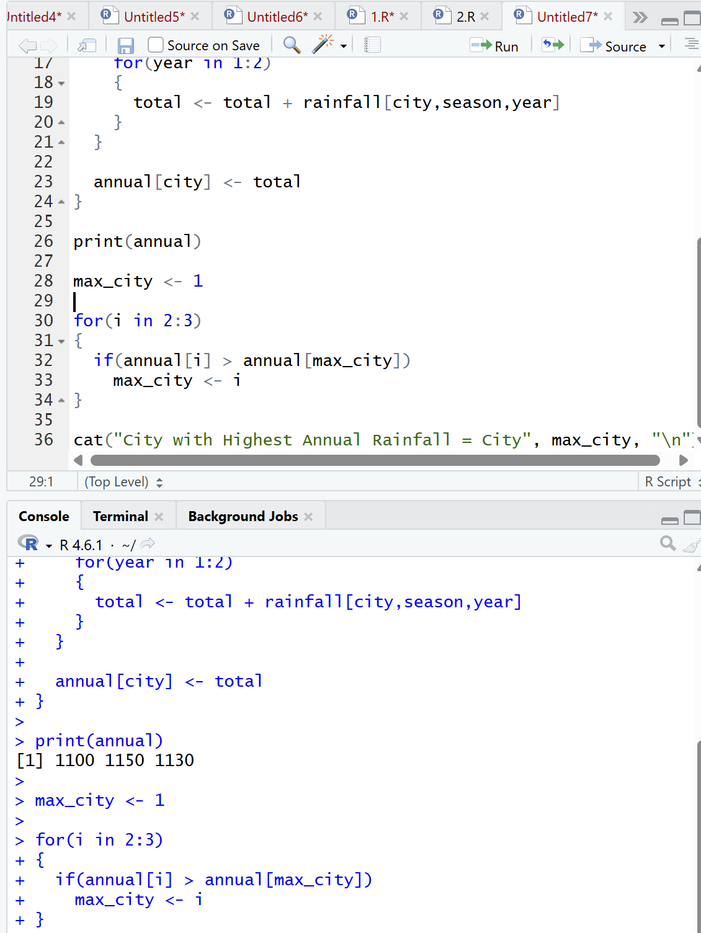

4. Hospital Patient Records (Lists)

# Hospital Patient Records
patients <- list(
ID=c(101,102,103,104,105),
Name=c("Arun","Bala","Chitra","David","Eva"),
Age=c(65,45,70,58,80),
BloodGroup=c("A+","B+","O+","AB+","A-"),
Bill=c(15000,10000,25000,18000,30000)
)
cat("Patients Above Age 60:\n")
for(i in 1:length(patients$Age))
{
if(patients$Age[i] > 60)
{
cat(patients$ID[i],
patients$Name[i],
patients$Age[i], "\n")
}
}
sum_bill <- 0
for(i in 1:length(patients$Bill))
{
sum_bill <- sum_bill + patients$Bill[i]
}
avg_bill <- sum_bill / length(patients$Bill)
cat("Average Hospital Bill =", avg_bill, "\n")
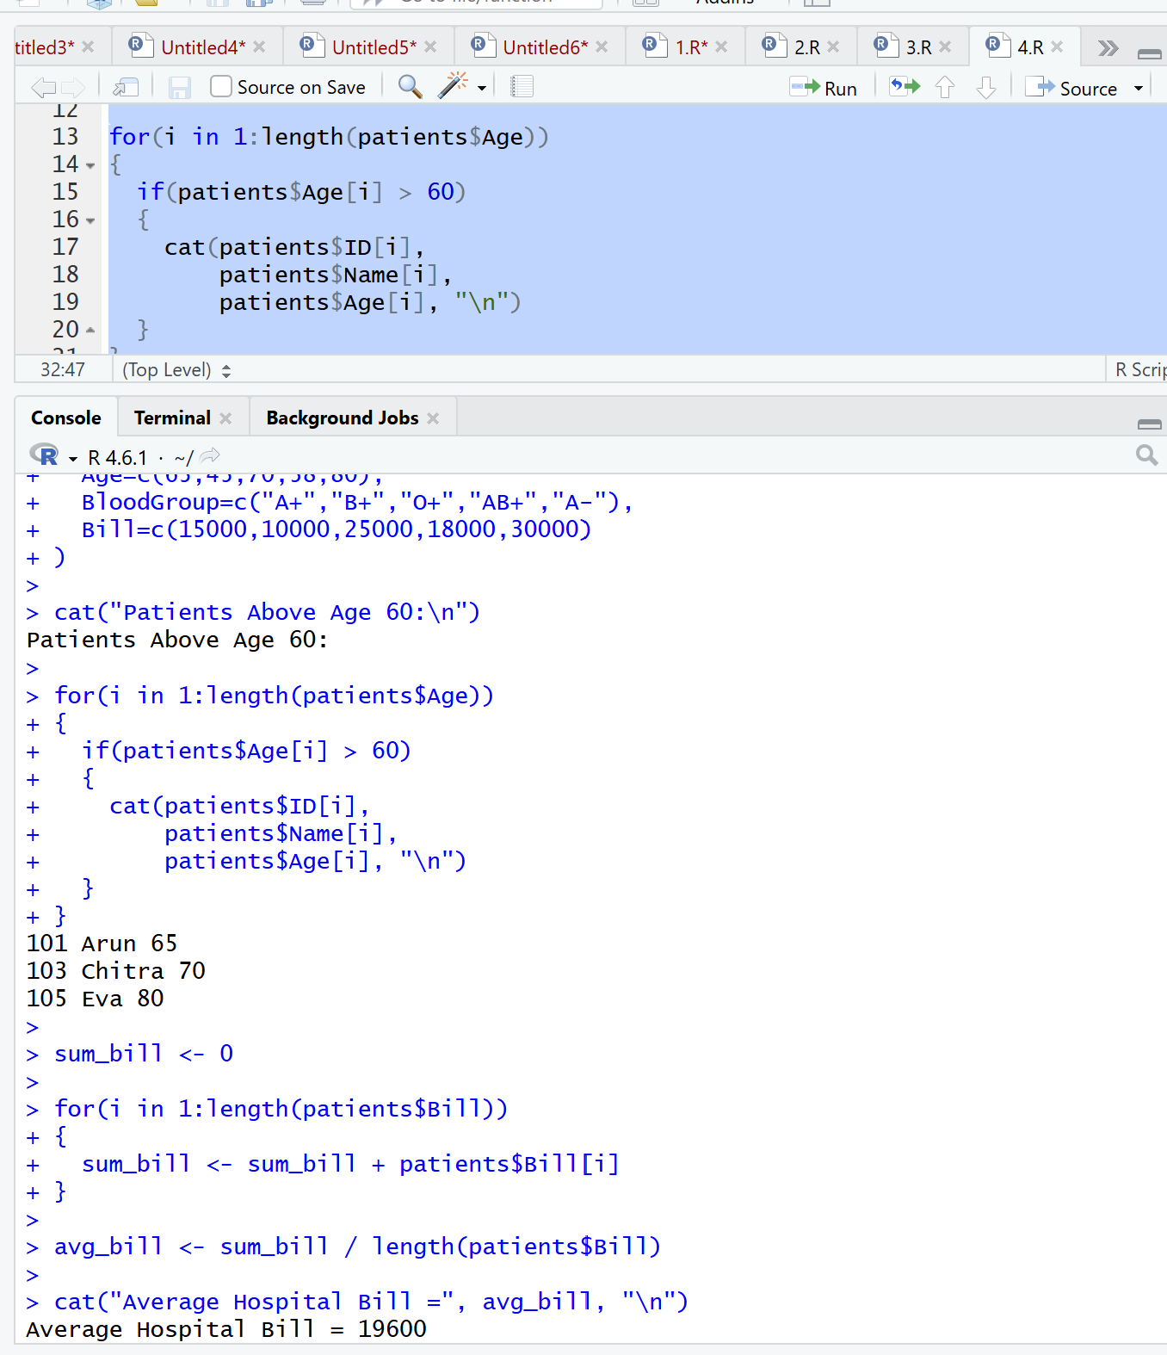

5. Product Inventory (Factors)

# Product Inventory
products <- factor(c(
"Electronics",
"Grocery",
"Stationery",
"Electronics",
"Grocery",
"Grocery",
"Stationery",
"Electronics"
))
levels(products) <- sort(levels(products))
cat("Categories in Alphabetical Order:\n")
print(levels(products))
count <- integer(length(levels(products)))
for(i in 1:length(products))
{
index <- as.integer(products[i])
count[index] <- count[index] + 1
}
for(i in 1:length(levels(products)))
{
cat(levels(products)[i], "=", count[i], "\n")
}

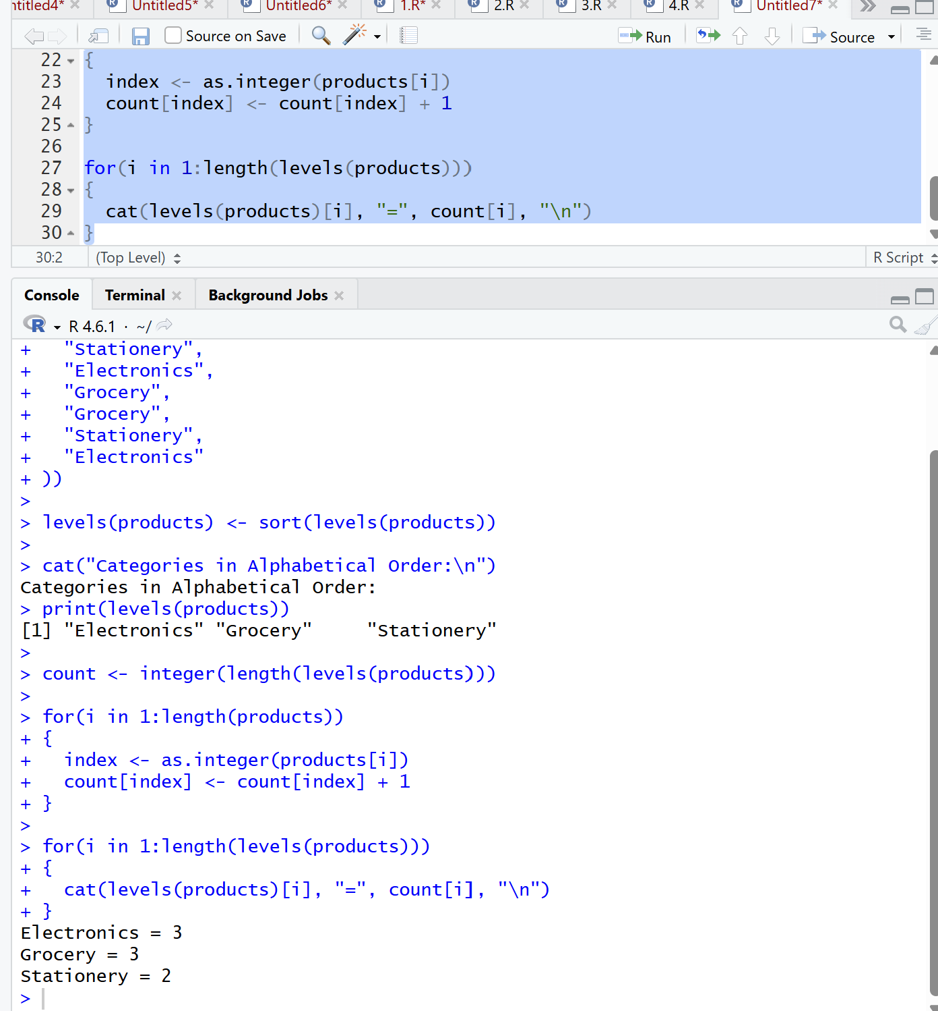

6. Cricket Performance Analysis (Data Frames)

# Cricket Performance Analysis
players <- data.frame(
Name=c("Virat","Rohit","Gill","Rahul","Hardik"),
Matches=c(100,90,50,70,80),
Runs=c(8000,7000,2500,4000,3500),
Wickets=c(5,10,2,1,60),
StrikeRate=c(135,118,128,110,145)
)
cat("Players with Strike Rate > 120:\n")
print(players[players$StrikeRate > 120,])
avg_runs <- sum(players$Runs) / nrow(players)
cat("Average Runs =", avg_runs, "\n")
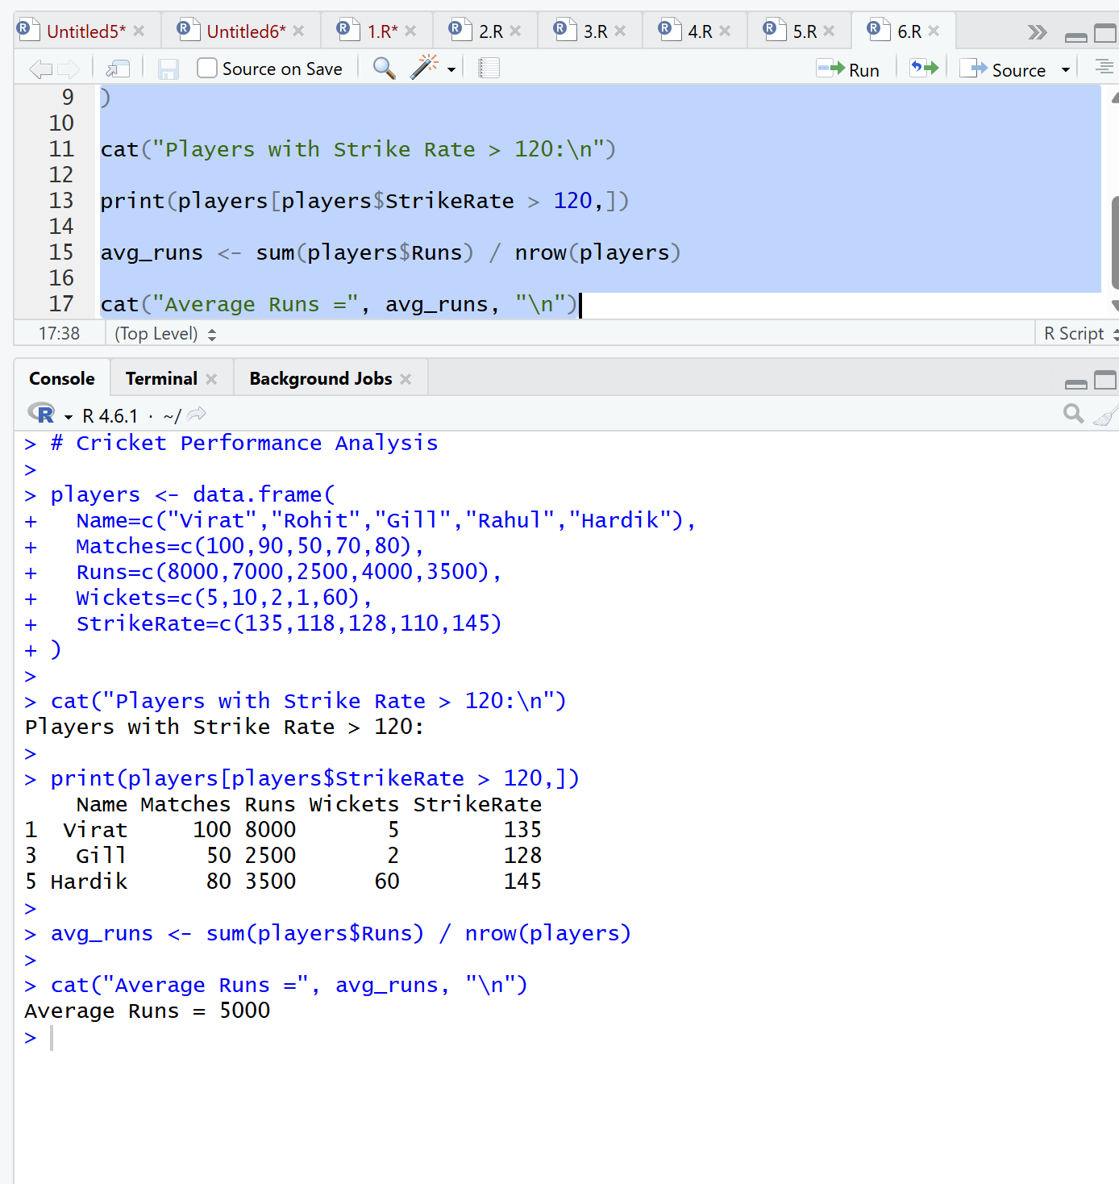
7. Bank Transaction Processing (Class Types)

# Bank Transaction Processing
bank <- data.frame(
AccountNo=c(101,102,103,104),
CustomerName=c("Amit","Bala","Charan","Deepak"),
Balance=c(50000,65000,45000,70000),
Status=c("Active","Inactive","Active","Inactive")
)
cat("Class of Each Column:\n")
print(sapply(bank, class))
bank$Status <- as.factor(bank$Status)
cat("\nAfter Conversion:\n")
print(sapply(bank, class))
cat("Balance Class =", class(bank$Balance), "\n")
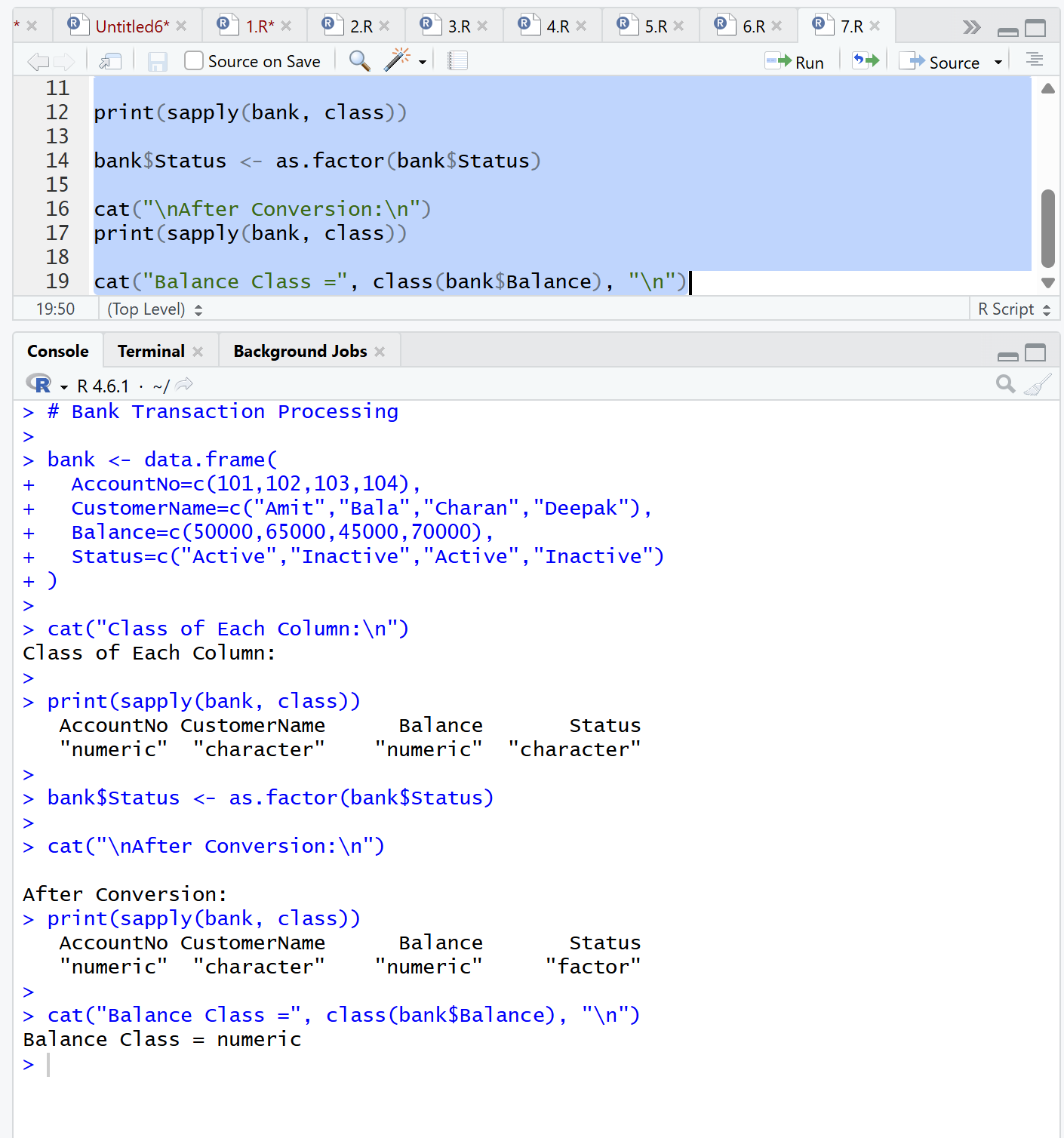
8. University Attendance Management (Vectors

# Attendance Management
attendance <- c(90,82,88,95,80,76,91,86,79,84,89,92,87,83,96)
eligible <- c()
ineligible <- c()
for(i in 1:length(attendance))
{
if(attendance[i] >= 85)
{
eligible <- c(eligible,i)
}
else
{
ineligible <- c(ineligible,i)
}
}
cat("Eligible Students:\n")
print(eligible)
cat("Ineligible Students:\n")
print(ineligible)
percentage <- (length(eligible) / length(attendance)) * 100
cat("Eligible Percentage =", percentage, "%\n")
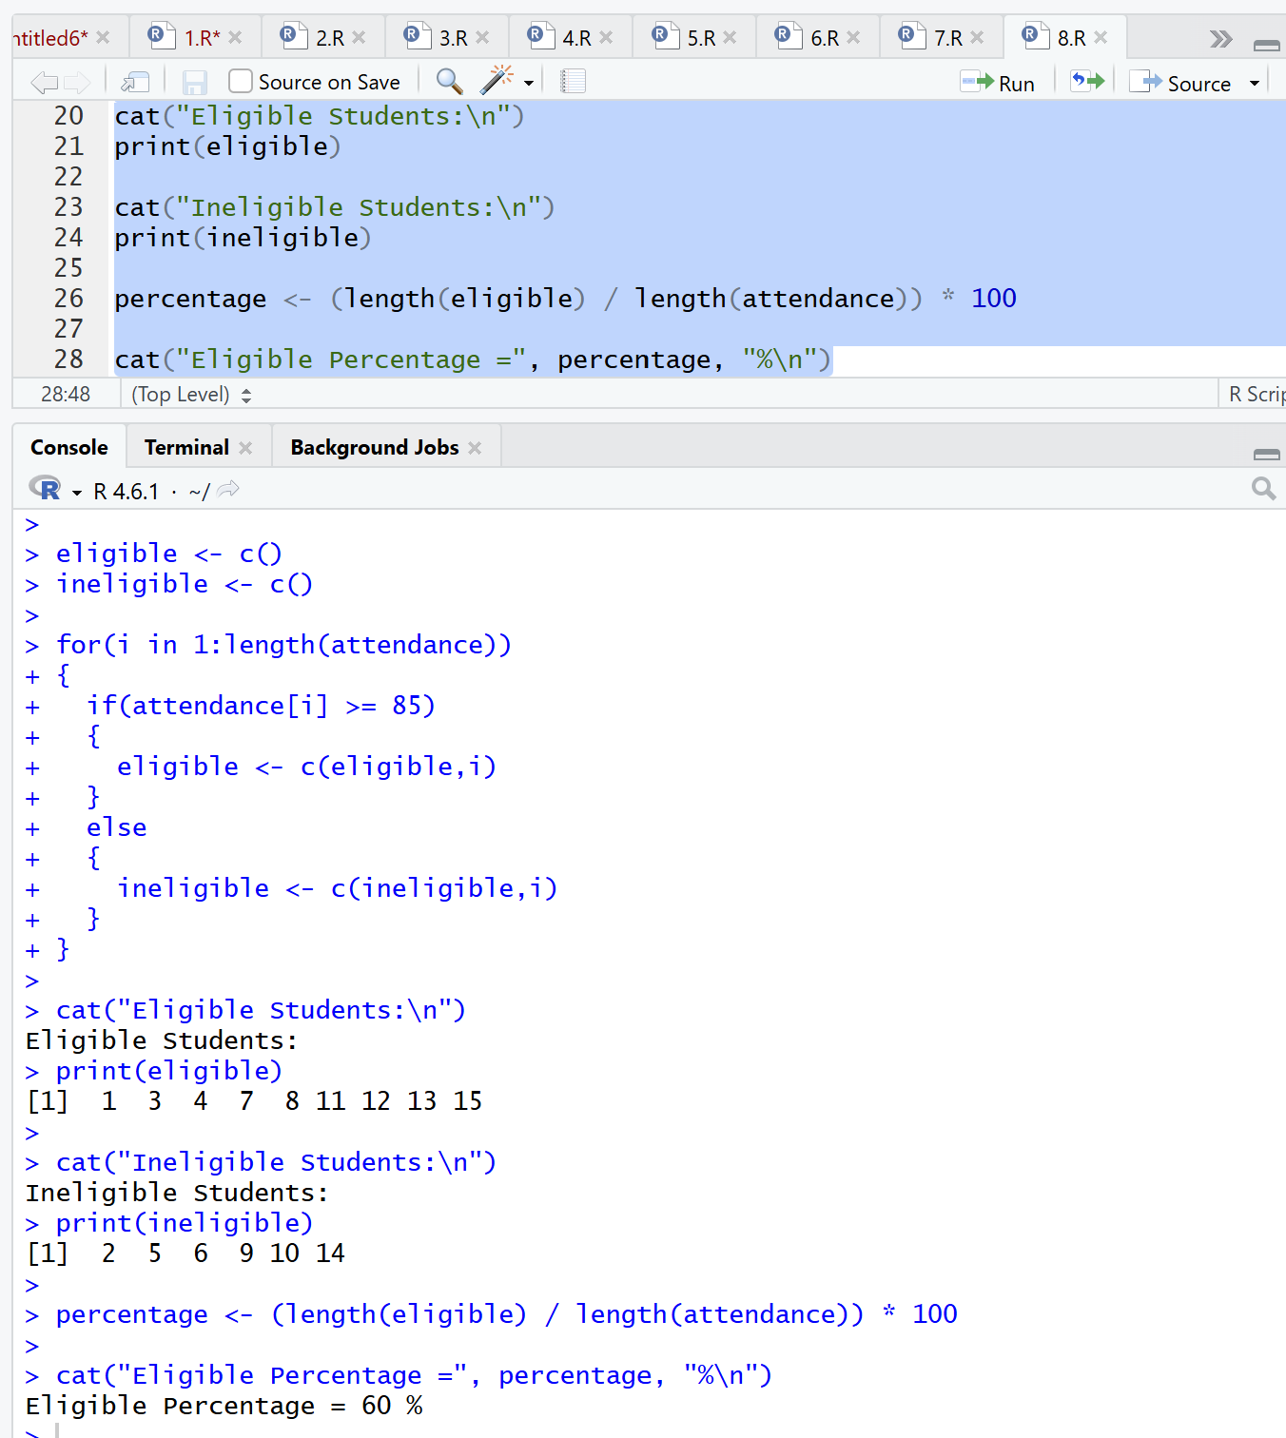

9. Electricity Consumption Analysis (Matrices)
# Electricity Consumption Analysis

consumption <- matrix(c(
200,220,210,215,225,230,240,235,220,210,205,215,
180,190,200,210,220,230,240,250,260,270,280,290,
150,160,170,180,190,200,210,220,230,240,250,260,
250,260,270,280,290,300,310,320,330,340,350,360,
170,175,180,185,190,195,200,205,210,215,220,225
), nrow=5, byrow=TRUE)
annual <- consumption %*% matrix(1,12,1)
cat("Annual Consumption:\n")
print(annual)
max_building <- which.max(annual)
cat("Building with Highest Consumption =", max_building, "\n")
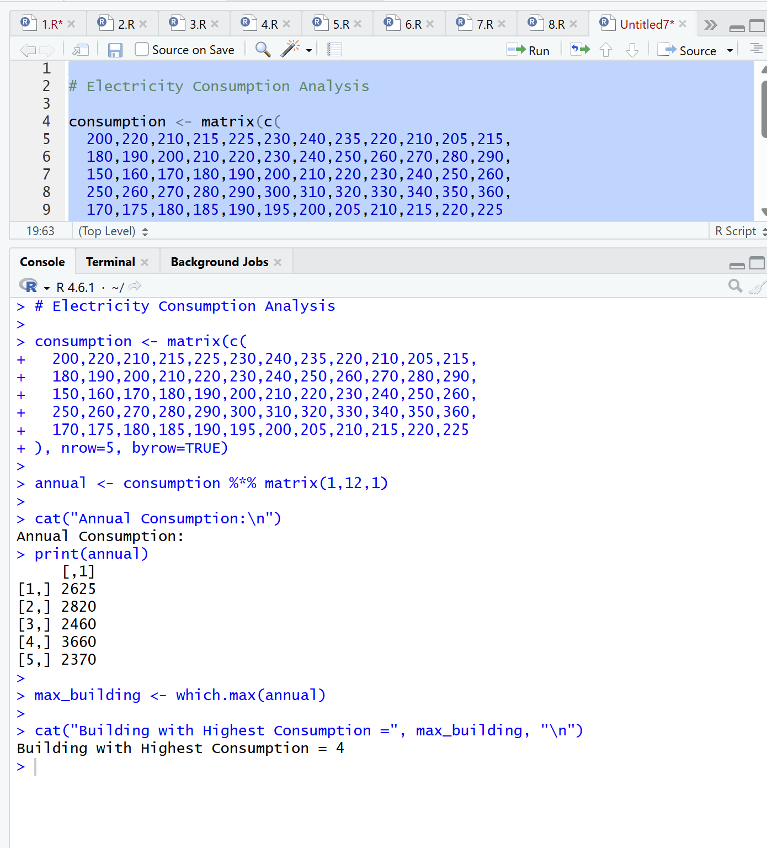

10. Sales Performance Dashboard

# Sales Dashboard
monthly_sales <- c(
12000,15000,18000,16000,17000,19000,
21000,22000,20000,23000,24000,25000
)
quarterly_sales <- matrix(c(
45000,52000,63000,
48000,55000,61000,
50000,57000,65000,
53000,60000,70000
), nrow=4, byrow=TRUE)
regional_sales <- array(c(
12000,13000,14000,15000,
16000,17000,18000,19000,
20000,21000,22000,23000
), dim=c(2,2,3))
categories <- factor(c(
"Electronics",
"Grocery",
"Stationery",
"Electronics"
))
cat("Class Types:\n")
cat("Monthly Sales:", class(monthly_sales), "\n")
cat("Quarterly Sales:", class(quarterly_sales), "\n")
cat("Regional Sales:", class(regional_sales), "\n")
cat("Categories:", class(categories), "\n")
annual_sales <- sum(monthly_sales)
cat("\nTotal Annual Sales =", annual_sales, "\n")
region_total <- c(0,0)
for(region in 1:2)
{
total <- 0
for(q in 1:2)
{
for(year in 1:3)
{
total <- total + regional_sales[region,q,year]
}
}
region_total[region] <- total
}
cat("Regional Totals:\n")
print(region_total)
best_region <- which.max(region_total)
cat("Best Performing Region =", best_region, "\n")
quarter_total <- rowSums(quarterly_sales)
cat("Quarterly Performance:\n")
print(quarter_total)

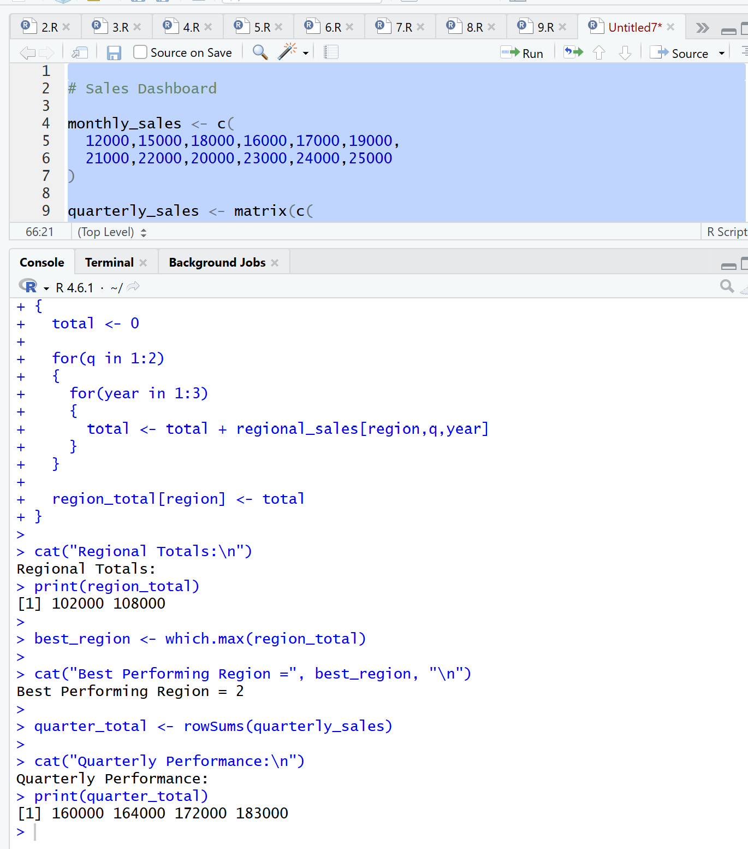

Criteria | Weightage | Level 4 – Exemplary | Level 3 – Proficient | Level 2 – Developing | Level 1 – Beginning
Problem Understanding | 20% | Identifies all inputs, outputs, constraints accurately | Minor missing elements | Partial understanding | Incorrect interpretation
Algorithm Design | 30% | Complete, correct, and logically sound solution | Minor logical gaps | Partially correct logic | Incorrect approach
Use of Control Structures | 20% | Efficient and appropriate use of loops, conditions, functions/modules | Minor inefficiencies | Limited or basic usage | Incorrect or missing constructs
Pseudocode Structure | 10% | Well-structured, clear, consistent format, easy to follow | Mostly clear with minor issues | Difficult to follow in parts | Poorly structured and unclear
Completeness | 20% | Handles all cases; optimized approach | Handles most cases; reasonable efficiency | Handles basic cases only | Incomplete or inefficient

